- Topics are case sensitive

EX:-
home/office/lamp
home/office/LAMP
- both are not same

MQTT BROKER:-

- Recieves all the messages
- filters the messages
- publishes the messages to all subscribed clients

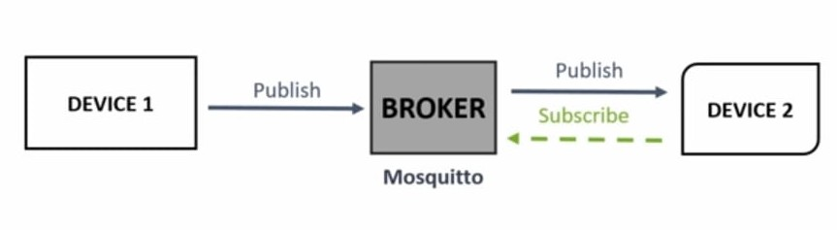

- Mosquitto broker is one of broker which will be install in the resberry pi

